**Brooklyn torah gazette**

**For parshas kedoshim 5779**

Volume 3, Issue 36 (Whole Number 132) 6 Iyaar 5779/ May 11, 2019

**Printed L’illuy nishmas Nechama bas R’ Noach, a”h**

For a free subscription, please forward your request to [***keren18@juno.com***](mailto:keren18@juno.com)

**Rav Avigdor Miller on**

**Raising Poor Children**

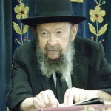

**QUESTION:** What is the *pshat* in the *ma’amar chazal* that tells us that we should be careful with poor children because they are the ones who will become *talmidei chachomim*?

**ANSWER:** In Mesichta Nedarim (91a) it says: שלחו מתם - “They sent a message from Eretz Yisroel: הזהרו בבני עניים – Be careful with the children of the poor, כי מהם תצא תורה – because from them Torah will come.” Torah comes from poor children. So the Ran asks: Why from poor children? Why is it that especially from the poor families will develop *talmidei* *chachomim*? And he says that it’s because poor children have nothing else but Torah.

Do you hear that? A rich boy has a bike and maybe he has a radio too; an automobile and all kinds of expensive toys he might have. He has a lot of things to keep him busy.

Boruch Hashem, when I was a boy, I never had a bike. I was such a poor boy that when I wanted to buy a little hammer - it cost twenty five cents in those days - I couldn’t afford it! It took me a long time but finally I saved up twenty five cents and I bought the hammer. That was a big thing for me! We didn’t have any toys.

Poor children have much less opportunities to waste their lives! Boruch Hashem! So הזהרו  – be careful, בבני עניים, with the poor, כי מהם תצא תורה, because Torah will come from them. And the Ran says it’s because they have nothing else to do except learn. That’s the *pshat* there. So now you know that children who have so many good things, it’s a very big problem. TAPE # 812

*Reprinted from the April 28, 2019 email of Toras Avigdor (Tape #812).*

**The Shmuz on****Parshas Kedoshi**

**Holiness is Natural**

**By Rabbi Bentzion Shafier**

**Founder of TheShmuz.com**

*“You shall be holy, for holy am I your G-d.” Vayikrah 19:2*

In this one sweeping statement the Torah assigns to us a mitzvah that seems well beyond our capacity – be holy. Even more perplexing this isn’t relegated only to the elite, or to the most pious. Rather, every Jew is commanded to be sacred.

This presents a number of problems. The first is that the mitzvah is extremely vague. If the Torah tells us to put on tefilin, it is clearly defined action, to be done with a particular object, at a specific time.

But what does it mean to be “holy?” How does one define it? And how does attain this lofty state? If this isn’t problematic enough, the basis of comparison makes it infinitely more difficult to understand. “You shall be holy, because I your G-d am holy.” In what manner, form or fashion can man’s holiness be compared to HASHEM’s?

In attempting to explain this mitzvah, the Ramban defines it as a general guideline against gluttony. He explains that the Torah permits pleasurable activities. One is allowed to eat many types of food. One may drink intoxicating beverages. A husband and wife are permitted to be together. As a result a person may become immersed in pleasures. This mitzvah is a general guideline to use indulgences properly, keep them in check—using them guardedly, judiciously.

While this Ramban is illustrative, he doesn’t seem shed much light on the issue. Controlling one’s desires is a fine concept, but how does that make a person sacred? It might stop him from become a hedonist, but, it won’t make him holy.

**The Nature of Man**

The answer to this question is based on a more focused understanding of human nature:

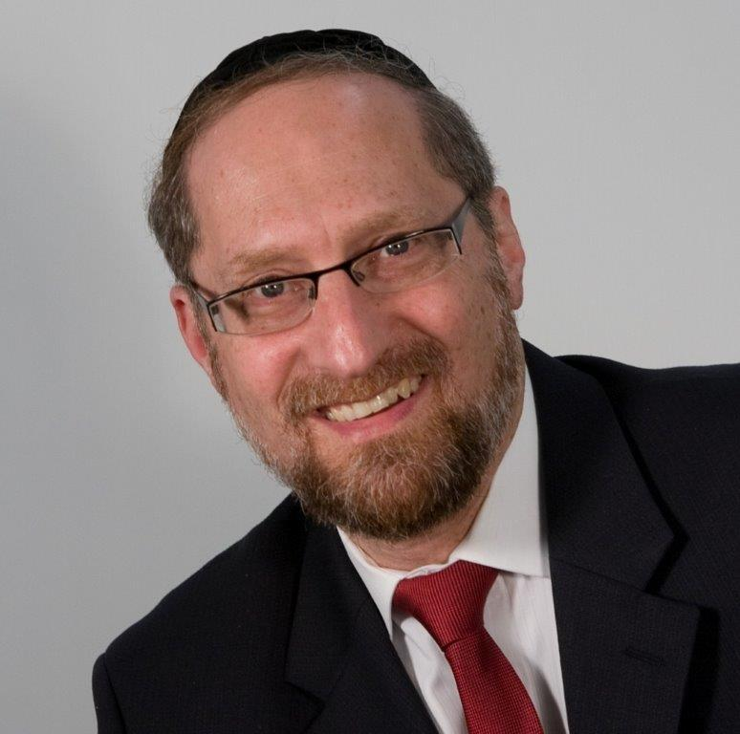

**Rabbi Bentzion Shafier**

The Chovos Ha’Levovos (Sha’ar Avodas Elokim) explains that HASHEM put into man two distinct components. The Nefesh Ha’Sichli, intellectual soul or neshama, and the Nefesh Ha’Bahami—the animal soul. The neshama comes from the upper worlds, and similar to the angels, only craves that which is good, right and proper. It deeply desires to be close to HASHEM. Its very essence strives for perfection.

The animal soul contains all of the drives that man needs to keep himself alive. Imprinted into it are the drives for food and drink, rest and shelter and all the other physical needs of man.

These two parts are diametrically opposed and are constantly battling for control of man. Each one cries out for its fulfillment, each one demands its needs. And, either one grows or shrinks based on usage. Much like a muscle that with use becomes strong and with disuse atrophies each part becomes stronger or weaker, based on how often it is allowed control. If man harnesses his desires, they become weaker and his pure intellect comes to the fore, eventually ruling over his animal soul. If he regularly gives in to his base desires, they become stronger and eventually dominant, till they govern over his neshama.

**A Pull to Holiness**

This seems to be the answer to the question on the Ramban. Within man, HASHEM implanted a Neshma so pure, that it pulls him to greatness. Its only desire is to be as much like HASHEM as it can be. HASHEM is perfect. HASHEM is holy. And so, Man’s neshama pulls to be perfect, to be as holy as much as a human can be.

The difficulty with man reaching this state, is that his animal soul tugs him towards everything temporal and passing. Its desires are immediate and mundane –the opposite of all that is holy and sublime. The more that man gives into these desires the stronger their pull on him. If left unchecked, they would turn him into an animal in the form of a man.

The Torah is teaching us that being holy isn’t foreign to us—quite the opposite, it’s part of our very nature. Half of of our personality only wishes for that which is elevated and proper. If we listen to that side, we will be holy. It’s instinctive. The difficulty is that there is another half of us that makes blocks us from reaching that state. To grow, we have to resist its call, and stand up against its pull.

Each of the mitzvahs guides us towards perfection. Do this and your nishama will shine. Don’t do this, as it will sully you, making it more difficult for you to actualize your potential.

**The Purpose of Creation**

With this mitzvah of “being holy”, The Torah is providing a guiding principle by which to use this world. Pleasures and enjoyments have their place. The Misilos Yesharim (perek 4) describes pleasure as tools to be used. When leveraged properly they can help to elevate a person.

When used as an aid to allow him a relaxed state of mind to better serve HASHEM – then they are tools for his growth. He becomes elevated through their use, and they become elevated by being used for their intended purpose. But he must be careful, because their pull is strong, and he can easily overuse them, and become less divine. Therefore the Torah warns us to practice moderation.

We learn from this mitzah that holiness is inborn in us. All we need do is the system to bring it out. The mitzvahs are that system. They guide to us to using this world as it was intended. When we do, we fulfill the reason for creation, and our purpose for being put into this world. We become more like HASHEM, we become holy.

*Reprinted from this week’s website on TheShmuz.com This is an excerpt from the [Shmuz on the Parsha book](https://theshmuz.com/product/shmuz-on-the-parsha-book/).*

**The Connection Between Ahavat**

**Yisroel and Loving Oneself**

**From the Talks of the Lubavitcher Rebbe**

**Rabbi Menachem Mendel Schneerson, Zt”l**

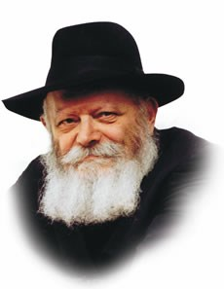

One of commandments contained in this week's Torah portion, Kedoshim, is the mitzva of ahavat Yisrael -- loving one's fellow Jew.

"You shall love your fellow as yourself," the Torah enjoins us. This mitzva is so important that Rabbi Akiva termed it "a great principle of Torah" -- the key to observe all Torah and mitzvot.

Rabbi Yisrael Baal Shem Tov, the founder of Chasidism, sought out the unlearned Jew, whose simplicity and sincerity placed him on a higher spiritual level than many sophisticated scholars.

Commenting on the Talmud's statement that the Jewish people are the two pairs of G-d's "tefilin," the Baal Shem Tov likened the simple Jew to the tefilin bound around the arm (symbolic of the deed), whereas the learned Jew is likened to the tefilin worn on the head (symbolic of the intellect). Just as tefilin are placed on the arm before the head, so too, practical deeds take precedence over intellectual knowledge.

Loving one's fellow Jew, therefore, involves respecting both the ignorant and the learned. In both these cases, however, the Jews in question are undeniably good. But what about those who are not? The Magid of Mezeritch, successor of the Baal Shem Tov, demanded that we love the absolutely wicked and the righteous in equal measure! The underlying reason is that when one concentrates solely on the Jew's inner essence, all Jews are equal and worthy of being loved.

Yet even this kind of love is somewhat limited, for when we say that one type of Jew should be loved like another, it implies that certain differences between them do exist, no matter how minute.

Rabbi Shneur Zalman, founder of Chabad Chasidism, taught that the love one Jew feels for another cannot be measured, much like the love between two brothers that stems from their very souls.

The commandment to "love your fellow as yourself" must therefore be taken literally: "as yourself." Just as self-love covers up a multitude of defects, so too must we love our fellow Jew with the same intensity.

Isn't this just a high ideal for which we strive but never hope to actually attain? Jews are different. Is it really possible to love a total stranger to the same degree one loves himself?

Yes! Although much has been written on the subject, suffice it to say that our love for each other is only a reflection of G-d's love for His children, the Jewish people.

Consequently, it is only natural that not only do we love G-d in return , but we extend that love to those whom He loves as well, without distinction.

In a deeper sense, however, the entire Jewish people may be said to comprise one collective whole, for the essence of every Jew is his soul, "a veritable portion of G-d Above." On this level, ahavat Yisrael is really loving ourselves, not some outside entity!

May we witness the greatest revelation of G-d's love for His children with the immediate Redemption by Moshiach.

*Reprinted from the Parashat Kedoshim 5755/1995 edition of L’Chaim Weekly (Issue #263), a publication of the Lubavitch Youth Organization in Brooklyn, NY.*

**Using Our Heads in Shul**

**By Rabbi Moshe Meir Weiss**

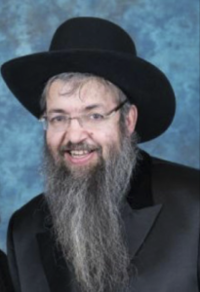

Here, on the eastern coast, spring finally seems to be here. It looks nearly certain that we won’t see snowplows until next year and, as the plants start to bloom and the temperatures rise, Klal Yisroel collectively takes out Pirkei Avos and starts its spiritual blooming as well.

During the days of sefira, we commemorate the ethical improvement and spiritual climb that our forefathers achieved from the moment of the Exodus until they were deserving of greeting G-d Himself forty-nine days later at Mount Sinai. Therefore, it is particularly fitting during this time of the year to learn Pirkei Avos, the premier syllabus for proper ethical behavior in Yiddishkeit.

Pirkei Avos is prefaced with the statement, “Kol Yisroel yeish lahem cheilek L’Olom Haba – Every Jew has a reserved portion in the Afterlife.” The Chida reveals a remarkable gematria. If you take the last letter of each word in this statement, “Kol Yisroel,” etc., their numbers total to 541, the exact gematria of Yisroel.

This again emphasizes the special privilege that each and every Jew has: An automatic spot in the Eternal World. This is one of the reasons why we are known as Yidden for, as the Gemora reveals in Masechtas Menachos, the letter yud is what Hashem used to create the Afterlife.

Thus, we are all Yidden since we all have a passport to the World that was created with the yud. So it follows that Pirkei Avos, which instructs us on how to live a moral and spiritually productive life, is prefaced with the Jew’s ultimate goal and ambition: To achieve the supreme joy of the Afterlife.

The study of Pirkei Avos contains lesson after lesson on how we can improve our daily behavior. Let me share with you one powerful example. In the second perek, we are taught, “Al taas tefilasecha k’va, ela rachamim v’sachanunim lifnei HaMakom – Do not allow your prayers to become fixed and habitual, but rather let them be sincere and concentrated expressions of supplications for mercy before Hashem.” The Tanna is warning us that since we say a prescribed formula of prayer day after day, it can easily be become mere lip service and a habit-like ritual.

I’d like to offer a mighty challenge. The next time you go to shul to pray, tell yourself that you’re planning to use your mind as much as your mouth in the synagogue – for proper service of Hashem has more to do with the mind and the heart than with the mouth.

Of course, we have to say our prayers but, as the Chovos Halevovos tells us, prayer without concentration is like a body without a soul and a peel without the fruit. Thus, I believe it is not wrong to say that we go primarily to shul to use our heads even more than our mouths.

Let me tell you what made me realize this idea. In another Mishna in the first chapter of Pirkei Avos, Shimon HaTzadik teaches us that the world stands on three pillars, Torah, Avoda (which is the service of Hashem), and Gemilas Chasodim, acts of kindness.

As we know, Yaakov Avinu introduced Torah to the world; Yitzchak introduced Avoda, while Avraham pioneered Gemilas Chasodim. The Chida explains more profoundly that there are three areas of challenge in one’s life: the world of action, the world of speech, and the world of thought.

He explains that Torah is the success for the arena of speech. Gemilas Chasodim is the success for the realm of action. Lastly, it is Avoda, especially prayer, which is the ultimate success for the world of thought. Thus we see revealed that, if one wants to excel at Avodas Hashem, he or she needs to be using their head while praying to Hashem.

May it be the will of Hashem that we train ourselves to use our minds as often as we can whenever we open the Siddur or Bentcher, when we say Krias Shema or the Shemona Esrei, and in that merit may Hashem fulfill all our prayers, blessing us with long life, good health, and everything wonderful.

*Reprinted from the Parshas Acharei Mos 5779 email of The Jewish Vues.*

**Rabbi Berel Wein on**

**Parashat K’doshim**

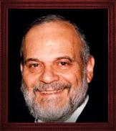

This week's Torah reading makes a heavy demand upon us. It commands us to be a holy and dedicated people and to continually aspire to heights of piety and holiness. Some will say that this is an almost impossible task and is especially difficult since the Torah does not define for us how it is to be achieved. But that is only a superficial understanding of what this Torah portion is coming to teach us.

In this Torah reading there appears a large amount – in fact a plethora – of commandments. At first glance one could mistakenly believe that this is nothing more than a jumble of laws thrown together almost at random without any discernible pattern or overall construction.

But upon careful examination one will come to realize that it is this wide variety of seemingly unconnected commandments and laws that form the ladder upon which one can ascend to the level of piety demanded from us by the opening verse of the reading.

Every phase of human life is covered by this very long list of do's and don'ts. They refer to personal behavior, the intimacy of marriage and the raising of children, commercial enterprises and all types of interactions between human beings. In effect, we are commanded to be as holy in the marketplace as we are in the synagogue and on a mundane weekday as we are on Yom Kippur.

It is in fact the very reason why there are so many commandments and so many laws and seemingly small details that make up Jewish life and values. Because human life is covered by the perspective of the demand for holiness on a constant basis, that is the goal of Judaism.

We live in a society that has mostly given up on the concept of holiness and dedication and functions only in the present and for today alone. We do not see a reverence for human life any longer, especially for infants and the unborn, nor any aspiration for spiritual growth at the expense of physical pleasure and leisure. There was a time that people ascribed attendance at a house of worship as being an act that could lead to holiness and spiritual development. Now, across the board of all faiths in the Western world today, attendance at houses of worship has declined drastically and the worship service itself has become one of entertainment, political correctness, guitar playing and social activities at best.

Only by strengthening the observance of the varied commandments that make up the bulk of this week's Torah reading can we at least glimpse the amount of holiness that we are ordained to attain. The sheer number of commandments that govern every aspect of Jewish life emphasizes to us the proportion of the task that lies before us.

There are no shortcuts to holiness and there are no instant remedies to the healing of society. Persistence and patience, repetition and tenacity remain today, as they have always been, the keys to Jewish life and to the fulfillment of the commandments that the Lord demands from us in order to be a holy and dedicated people.

*Reprinted from this week’s website of Rabbiwein.com*

**Kedusha is for Everyone**

**Rabbi Eli J. Mansour**

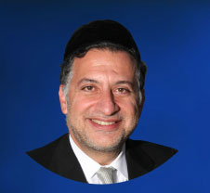

Parashat Kedoshim begins with the commandment of "Kedoshim Tiheyhu" – "You shall be holy."  When G-d issues this command to Moshe, He emphasizes that Moshe must convey it to "Kol Adat Benei Yisrael" – "the entire assembly of the Israelite people."

The Mitzva to live a life of Kedusha, sanctity, is not restricted to the great Torah sages in Jerusalem and Bnei-Brak, or to the thirty-six hidden Tzadikim in the world.  It applies to "the entire assembly of the Israelite people," to each and every Jew, regardless of his background or current stature.

This Mitzva serves as a powerful expression of how much the Almighty thinks of each and every individual, how He believes in every Jew's potential for greatness.  People often look back in despair at their past mistakes and improper behavior.

They think to themselves, "Holiness can't be for me; anyone who knows the things I did would never expect me to become 'Kadosh'."  But the Torah tells us that nothing can be further from the truth.  "Kedoshim Tiheyu" is an obligation that the Torah casts upon each and every one of us, irrespective of what we have done in the past.

In fact, the Talmud teaches that "the place where Ba'alei Teshuva [repentant sinners] stand – completely righteous people cannot stand there."  People with a history of sin face a much greater challenge than those who have been sheltered and protected from sin their entire lives.  Having already enjoyed the forbidden pleasures of the world, it is far more difficult for them to withdraw and commit themselves to a life of observance.  In a certain sense, then, their potential for "Kedusha" is even greater than that of perfect Tzadikim!

The story is told of a lecturer who spoke to an audience and took from his pocket a $100 bill.  "Who wants this bill?" he asked.  Naturally, everybody in the audience emphatically exclaimed that they would want the bill.  The speaker then crumpled the bill and opened it again, so that it appeared wrinkled.  He repeated his original question: "Who wants this bill?"  Once again, the entire room shouted to express their desire to have the money.  The speaker then placed the bill on the floor and trampled on it.  When he finished, he lifted it and showed the audience how dirty and dusty it looked.  For the third time, he asked, "Who wants this bill?"  Of course, the question elicited the same response that it had on the previous two occasions.

The lecturer then explained the meaning behind this exercise.  No matter what a person does to a $100 bill, it remains valuable, it does not lose its worth, and everybody is as eager to own it as they were when it was clean and fresh.  The same is true about G-d's feelings towards every individual.

As we grow through life, there are times when we become "crumpled" or "dirty," when we act inappropriately and make mistakes.  But even when this happens, we are still as valuable in G-d's eyes as we were initially.  He believes in our potential for Kedusha regardless of our past, and we should therefore believe in ourselves and strive for holiness, without being discouraged by our past mistakes.

*Reprinted from this week’s website of the Edmund J. Safra Synagogue in Brooklyn, NY.*

**Our Protection**

**By Rabbi David Ashear**

The pasuk says in Kohelet, “someone who does a mitzvah will never see any harm from it. The mitzvot are our protection. They shield us from harm. Following the will of Hashem only brings goodness, whether we see it or not. People who trust in Hashem are never afraid to do a mitzvah, even when it looks like they might lose out as a result.

A Rabbi told me, one of his congregants, who we’ll call Joe, came to him about a year and a half ago asking for help. His business had not been successful, and he was forced to close it down. It got to a point where he needed to ask the Rabbi for charity funds, just to be able to feed his family.

The Rabbi helped him, giving him a few hundred dollars a week from his chesed fund. A couple of months later, a different congregant from his shul, who we’ll call Ezra, came to the Rabbi for advice. Joe had asked him if he would invest with him in a new business, but he was very apprehensive about doing so. He explained to the Rabbi, “Joe hasn’t had any success in business for the last fifteen years. Maybe he has bad luck? I don’t want to lose my money.”

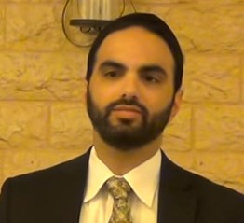

**Rabbi David Ashear**

The Rabbi replied he just read, the night before, a piece from the sefer Chafetz Chaim which addressed this very point. He said the Chafetz Chaim was talking about the laws of warning people not to partner up in business with someone who is dishonest. And there he wrote, “Don’t make a mistake and think that this applies to someone who is poor and down and out. It would be absolutely forbidden to tell somebody not to go into business with someone else because he had been unsuccessful in the past. Just because he didn’t have success before, doesn’t mean he won’t have success now.”

And then the Chafetz Chaim added, “In fact, it is just the opposite. No harm could ever come out of giving tzedaka; and to help somebody by putting him into business is the highest form of tzedaka. Even if the investor would only have personal motives in mind, he would still get credit for this high form of tzedaka. All the more so if he does it with the right intentions. The Chafetz Chaim concluded with a saying of Chazal, talking about how a person will only be blessed for the tzedaka that he gives.

When Ezra heard those words, he told the Rabbi, “If that”s the case, I’m going to happily invest with Joe.”

The partnership was formed and they made a goal of how much money this company should be worth over the next five years. Fast forward eight months: The company had already surpassed the five year goal. They have experienced Siyata D’Shamaya in ways they never could have dreamed.

This business has given hundreds of thousands of dollars to charity in its first year. Joe went from taking a few hundred dollars of tzedaka a week to feed his family to giving away thousands of dollars a week to help others, in the same year. Ezra trusted in the words of our Torah and saw immediate, out of the ordinary, gains from it. This was clearly a test for him, set up by Hashem. The Rabbi happened to see that Chafetz Chaim just hours before this question was posed to him-it was hashgachat Hashem. Ezra passed the test and saw much beracha as a result.

We can never lose out by doing a mitzvah; we only gain. And our emunah in that principle can make the gains even greater.

*Reprinted from the May 2, 2019 email of Living Emunah.*

**The Living Jew of Warsaw**

**By**[**Mordechai Lightstone**](https://www.chabad.org/search/keyword_cdo/kid/13002/jewish/Lightstone-Mordechai.htm)

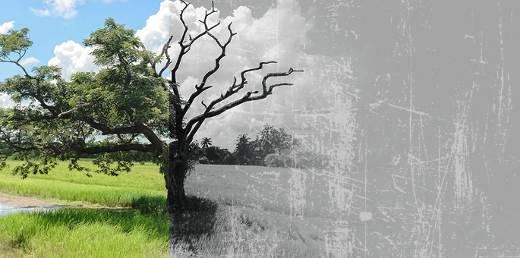

I spent my school year in 2006 visiting mass graves.

Based out of the Chabad center in Warsaw, Poland, my cohort of fellow yeshivah students and I spent the year in what we considered the ashes of the Holocaust. Sure, there were a lot of firsts—the first impromptu [bar mitzvah](https://www.chabad.org/library/article_cdo/aid/1912609/jewish/Bar-Mitzvah-When-It-Is-and-How-to-Celebrate.htm) with a Jew from Bialystok, the first kosher[Shabbat meal](https://www.chabad.org/library/article_cdo/aid/2995074/jewish/What-to-Expect-at-a-Shabbat-Dinner.htm) in Wrocław, etc., but mostly our experiences seemed to center around mass graves. In Warsaw, in Majdanek, and wherever we traveled in Poland—the memory of what once was loomed inescapably.

Until I met Jakob.

I first noticed him shortly after I came to Warsaw, and I watched as week after week he came to *shul* on Shabbat afternoon for the*minchah* service, sat at the back and prayed silently.

His dark eyes, narrowed in concentration, gave him the air of someone far older than his almost thirty years, and with the thin goatee and hat he sported (which fell somewhere between a French beret and a Russian cap), he resembled a beatnik, or perhaps a Soviet Refusenik.

When three stars appeared in the night sky—symbolizing the end of Shabbat and the start of a new week—he would listen to [*Havdalah*](https://www.chabad.org/library/article_cdo/aid/256963/jewish/What-Is-Havdalah.htm), take a sip from the cup of wine, and then leave, always with his *siddur*in hand. Save for a perfunctory nod or *shavua tov*, we never spoke.

Until one week, as I milled around the sanctuary after the prayers had ended, he approached me, purple *siddur* clutched to his chest, thumb held between the pages to keep his place. Looking me up and down, as if his eyes were scanning the whole of my character, he opened the *siddur* and held it in front of me. “Perhaps you could help me . . .”

The other congregants trickled out as we spoke, and soon only the two of us remained.

His name was Jakob Wejnsztein, I discovered, and although he had never left Poland for more than a few weeks at a time, his English was flawless, if heavily accented.

“I don't like the West . . .” he told me, nostrils flaring, eyes narrowed to slits.

“Why not?” I asked. After all, what did Eastern Europe offer to a Jew in search of spiritual growth?

“I don't like it because of how people see me there . . . It's the same reason I don't visit Auschwitz.”

Seeing the look of shock on my face, he sighed.

“I am a living Jew. Not a dead one. To you Americans, we are all dead. You come here to see the destruction of our people. You come to feel sorry for what happened, or even worse, to feel sorry for yourselves. But it doesn't change you. You go home to everything you left and resume life as before.

“You cannot understand us. To Western Jews, the only Jew in Poland is a dead Jew.

I, however, am a living Jew. I pray three times a day, I learn Torah—from books and online. I am as alive as every other member of our nation.

“I know what happened 60 years ago; I live with it every day of my life. It surrounds me. Every street cries, blood soaked into its stones. But I didn't die like them. No. I live for them, and they live through me.”

His words poured out thickly, their energy tangible in the still air of the now-empty synagogue. And as I listened, I realized he was right. I, too, had seen him as an anomaly, a strange creature of the past.

The origin of the word Holocaust is the Greek *holokausto,* “burnt whole,” a sacrifice consumed by fire. Indeed, Polish Jewry had been sacrificed—a thousand years of history uprooted and destroyed, the surviving remnants replanted elsewhere.

The Warsaw, Vilna, and Pressburg of the past became the Jerusalem, Brooklyn, Los Angeles, and London that we know. Jakob did not fit with that picture. He lived in a land that existed only in my mental image of times long gone. Surely there was no future for a Jew here.

Yet here I was, in a synagogue built over the rubble of the ghetto, praying in the very place where the train tracks to Treblinka had once clattered a death knell, and Jakob—the child of Jews who chose to remain in Poland, who grew up in the shadow of Communism—was here as well. What right did I have to view him as anything other than the spiritual, passionate Jew he clearly was? Not a relic of some forgotten world; a living Jew! In my ignorance, I had unknowingly judged him . . .

We wrapped up the conversation and wished each other s*havua tov*, but this time it was far from the perfunctory nod of the past.

In my mind, perhaps only one living Jew had entered the *shul*, but two had most definitely left. Not only had Jakob found a new breath of life in Judaism, but now, thanks to our conversation, so had I.

That lesson still rings true almost 13 years later. Too often, when we speak about the joys of Judaism, we focus on the *oy.*A history of destruction—Crusades, Inquisitions, Pogroms, Holocausts, and Intifadas loom in our minds. But we must be careful not to let our Judaism die for the past.

Our ancestors endured that suffering so that we would be able to live Jewishly, openly and proudly, in ways they couldn’t even imagine. It’s our responsibility to bring that life—the one they so longed for—into fruition. Say [Kaddish](https://www.chabad.org/library/article_cdo/aid/514160/jewish/Kaddish.htm" \o "Kaddish) for the past, but don’t forget to sing the song of the living Jew too.

*Reprinted from the Parashat Acharei Mos 5779 email of Chabad.Org Magazine.*

**Utilizing Good Middos to**

**Become More Confident Parents**

**Of Happy Competent Children**

**By Daniel Keren**

(“Confident Parents - Competent Children: Four Seconds at a Time” by Rabbi Yitzchak Shmuel Ackerman, Feldheim Distributors, 221 pages, 2018)

 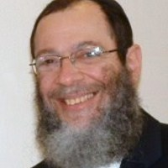

Rabbi Ackerman

There are many parenting books constantly being published as in each and every generation, social mores change and what worked for parents of recent decades won’t be of value to today’s parents. Does anyone still read Dr. Spock’s once classic book on raising babies and children?

Also what non-Jewish parents believe is helpful or want for their children won’t be good for parents in our community who want to raise boys and girls to be continuing links in the Mesorah (traditions) of Klal Yisroel going back to Har Sinai.

There is no shortage of parenting books in the Jewish religious community, and most are geared to particular segments of the Jewish nation (i.e. Modern Orthodox, Chassidic, Yeshivish, etc.)

Rabbi Yitzchak Shmuel Ackerman has just published a book titled “Confident Parents – Competent Children: Four Seconds at a Time” based on more than 35 years of his professional experience in offering parenting courses, which he currently does at the Lighthouse Youth and Family Counseling Center.

What caught my attention was Rabbi Ackerman’s focus on utilizing good middos (character traits) such as anavah (humility,) hakaras hatov (appreciation,) dan l’kaf zechus (judging favorably,) savlanus (tolerance,) emes (truth,) kabbalah (acceptance,) etc. to help parents create positive and loving connections with their children.

In discussing the ideal of an effective parent, the author lists two important goals parents should make for themselves: (1) develop appropriate expectations for each of their children and (2) make the effort to help each child reach those expectations.

Most of Rabbi Ackerman’s preface to his parenting book as mentioned above focuses on the importance of utilizing good middos to become an effective parenting, with the reward being that those middos will help you to not only elicit the thoughts, feelings and desires of your child without putting him on the defensive; avoid needless arguments with your child; eliminate misunderstandings with your child; and feel less resentment, anger and frustration as a result of your interactions with your children.

The author declares that his book is premised on the important concept of “Mitzvos tzerichos kavanah” or “begin with the end in mind.” If parents don’t know what they desire their children to develop into and become, they might not wind up with adult children whose values they can admire. And the ultimate obligation of a parent is to help their child become the best that child can hope for.

One example is the author’s response to the frustration of many parents who complain that their children don’t have an interest in davening (praying.) He writes:

“Often, when a child isn’t interested in davening, the problem is one of meaning. Either he doesn’t know what the words mean, or he knows what the words mean but finds them boring and a waste of time when he would rather be enjoying breakfast or talking with his friends.

“If he doesn’t know what the words mean, a linear, phrase-by-phrase translation might be helpful. But what do you do if he knows the translation but doesn’t see how the words are relevant to him?...

“[Your son] thinks davening doesn’t have much value. Invite him to think about it differently. Here’s how:

“Tell him, ‘Please write down thirteen things that you think we ask for from Hashem when we daven.’

“I first gave this assignment as a Hebrew school teacher of twelve-year-olds in 1974. The boys and girls in my class suggested some very thoughtful and compassionate requests, which I wrote on the board.

“Then they opened their siddurim [prayer books] and we looked at the thirteen requests in the weekday Shemoneh Esrei. We analyzed the list on the board and discovered that they had intuited much of what the Anshe Knesses HaGedolah, the Men of the Great Assembly who composed that prayer, had put into words.

“What a wonderful discovery for those children! They were able to see how closely their wishes and hopes aligned with those of some of the wisest sages of all time.”

So in addition to developing one’s middos in an effort to become the confident parents that can help one’s child become more competent, one should never ever forget the importance of utilizing the concept of tefillah to pray to Hashem for 24/7 help in making a good connection with your child(ren). After all even if you try to use the many techniques found in Rabbi Ackerman’s new book, it all comes down in the final analysis to siyata d’shemaya (heavenly assistance.)

“Confident Parents – Competent Children: Four Seconds at a Time” by rabbi Yitzchak Shmuel Ackerman can be found in bookstores or obtained from the distributer by either calling (800) 237-7149 or emailing [sales@feldheim.com](mailto:sales@feldheim.com)

*Reprinted from the May 9, 2019 edition of The Jewish Connection.*